Ms Sarah Bird  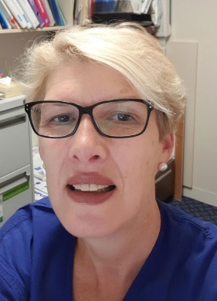 | RN, RM, Grad Dip Hlth. Mgt and Info Systems, Perioperative Management Cert, Cert IV Training & Assessment, Laser Safety Officer certificate. MACN, MIFPN, FACORN,FAAQHC  Employment history  Sarah is currently the Perioperative Quality and Education Coordinator including Policy, Radiation portfolio’s, at Hobart Private Hospital, Tasmania, Sarah has held this position from 2014.  Sarah has worked within the Health sector for 30 years moving to Tasmania in 1986. Sarah previously was ADON Perioperative Services role from 1999- 2014 at Hobart Private Hospital. Sarah has been actively involved with the Australian College of Perioperative Nurses (ACORN) at State, National and International level. Roles at ACORN included State President, ACORN Board member 2012-2018, Including holding the role of ACORN Journal Editor ( 2014-2016). Sarah, is a Past President of ACORN 2016-2018 and has just completed a term as Board Secretary 2018-2021 on the International Secretariat of IFPN International Federation of Perioperative Nurses (IFPN). She maintains her ACORN contact being an ACORN Tasmania Committee member and also on the ACORN Censor Panel.  Sarah is part of the Hobart and Healthscope National Private Quality team and several other Healthscope National committees. In 2019 was the Private Hospital Associations Representative on the ACHS review of the ACHS Anaesthetic Clinical Indicators.  Expertise  Sarah has extensive management experience at local hospital and national private hospital organisations Including Healthscope, Mayne Health and Calvary Health Care with active participation in in policy development, project management, leadership, change management, organisational reform, quality and safety and corporate and clinical governance. Sarah has wide-ranging expertise and interests in surgical patient safety, infection control, and education. Sarah’s passion to ensure safe patient care which is central to the time she has held positions on ACORN board, Sarah has spoken at local , national and International conferences on related Perioperative topics. In 2019 Sarah was keynote speaker at ASIORNA International Asian Summit, in Kuala Lumpur , discussing Patient Safety in the Perioperative Setting and Communicating the key to success.  Sarah is passionate about staff training and has a keen interest in online education and training. A strong advocate for quality and safety and the principles of accreditation Sarah has participated on strategic planning and quality improvement committees at all levels, providing education programs related to patient care and safety and all areas of NSQHS Standard training to her current work employees.  In 2019 Completed ACSQHC Assessor training and ACHS Assessor training. COVID 19 and isolation in Tasmania curtailed till commencing Hospital facility assessing. In 2020 I commenced consulting as an ACSQHS qualified assessor with Quality Innovation Performance , QIP and Global Mark.  In 2021 I was awarded a fellowship to AAQHC and in 2022 completed further quality training with a Lead Auditor TAFE skill set module.

